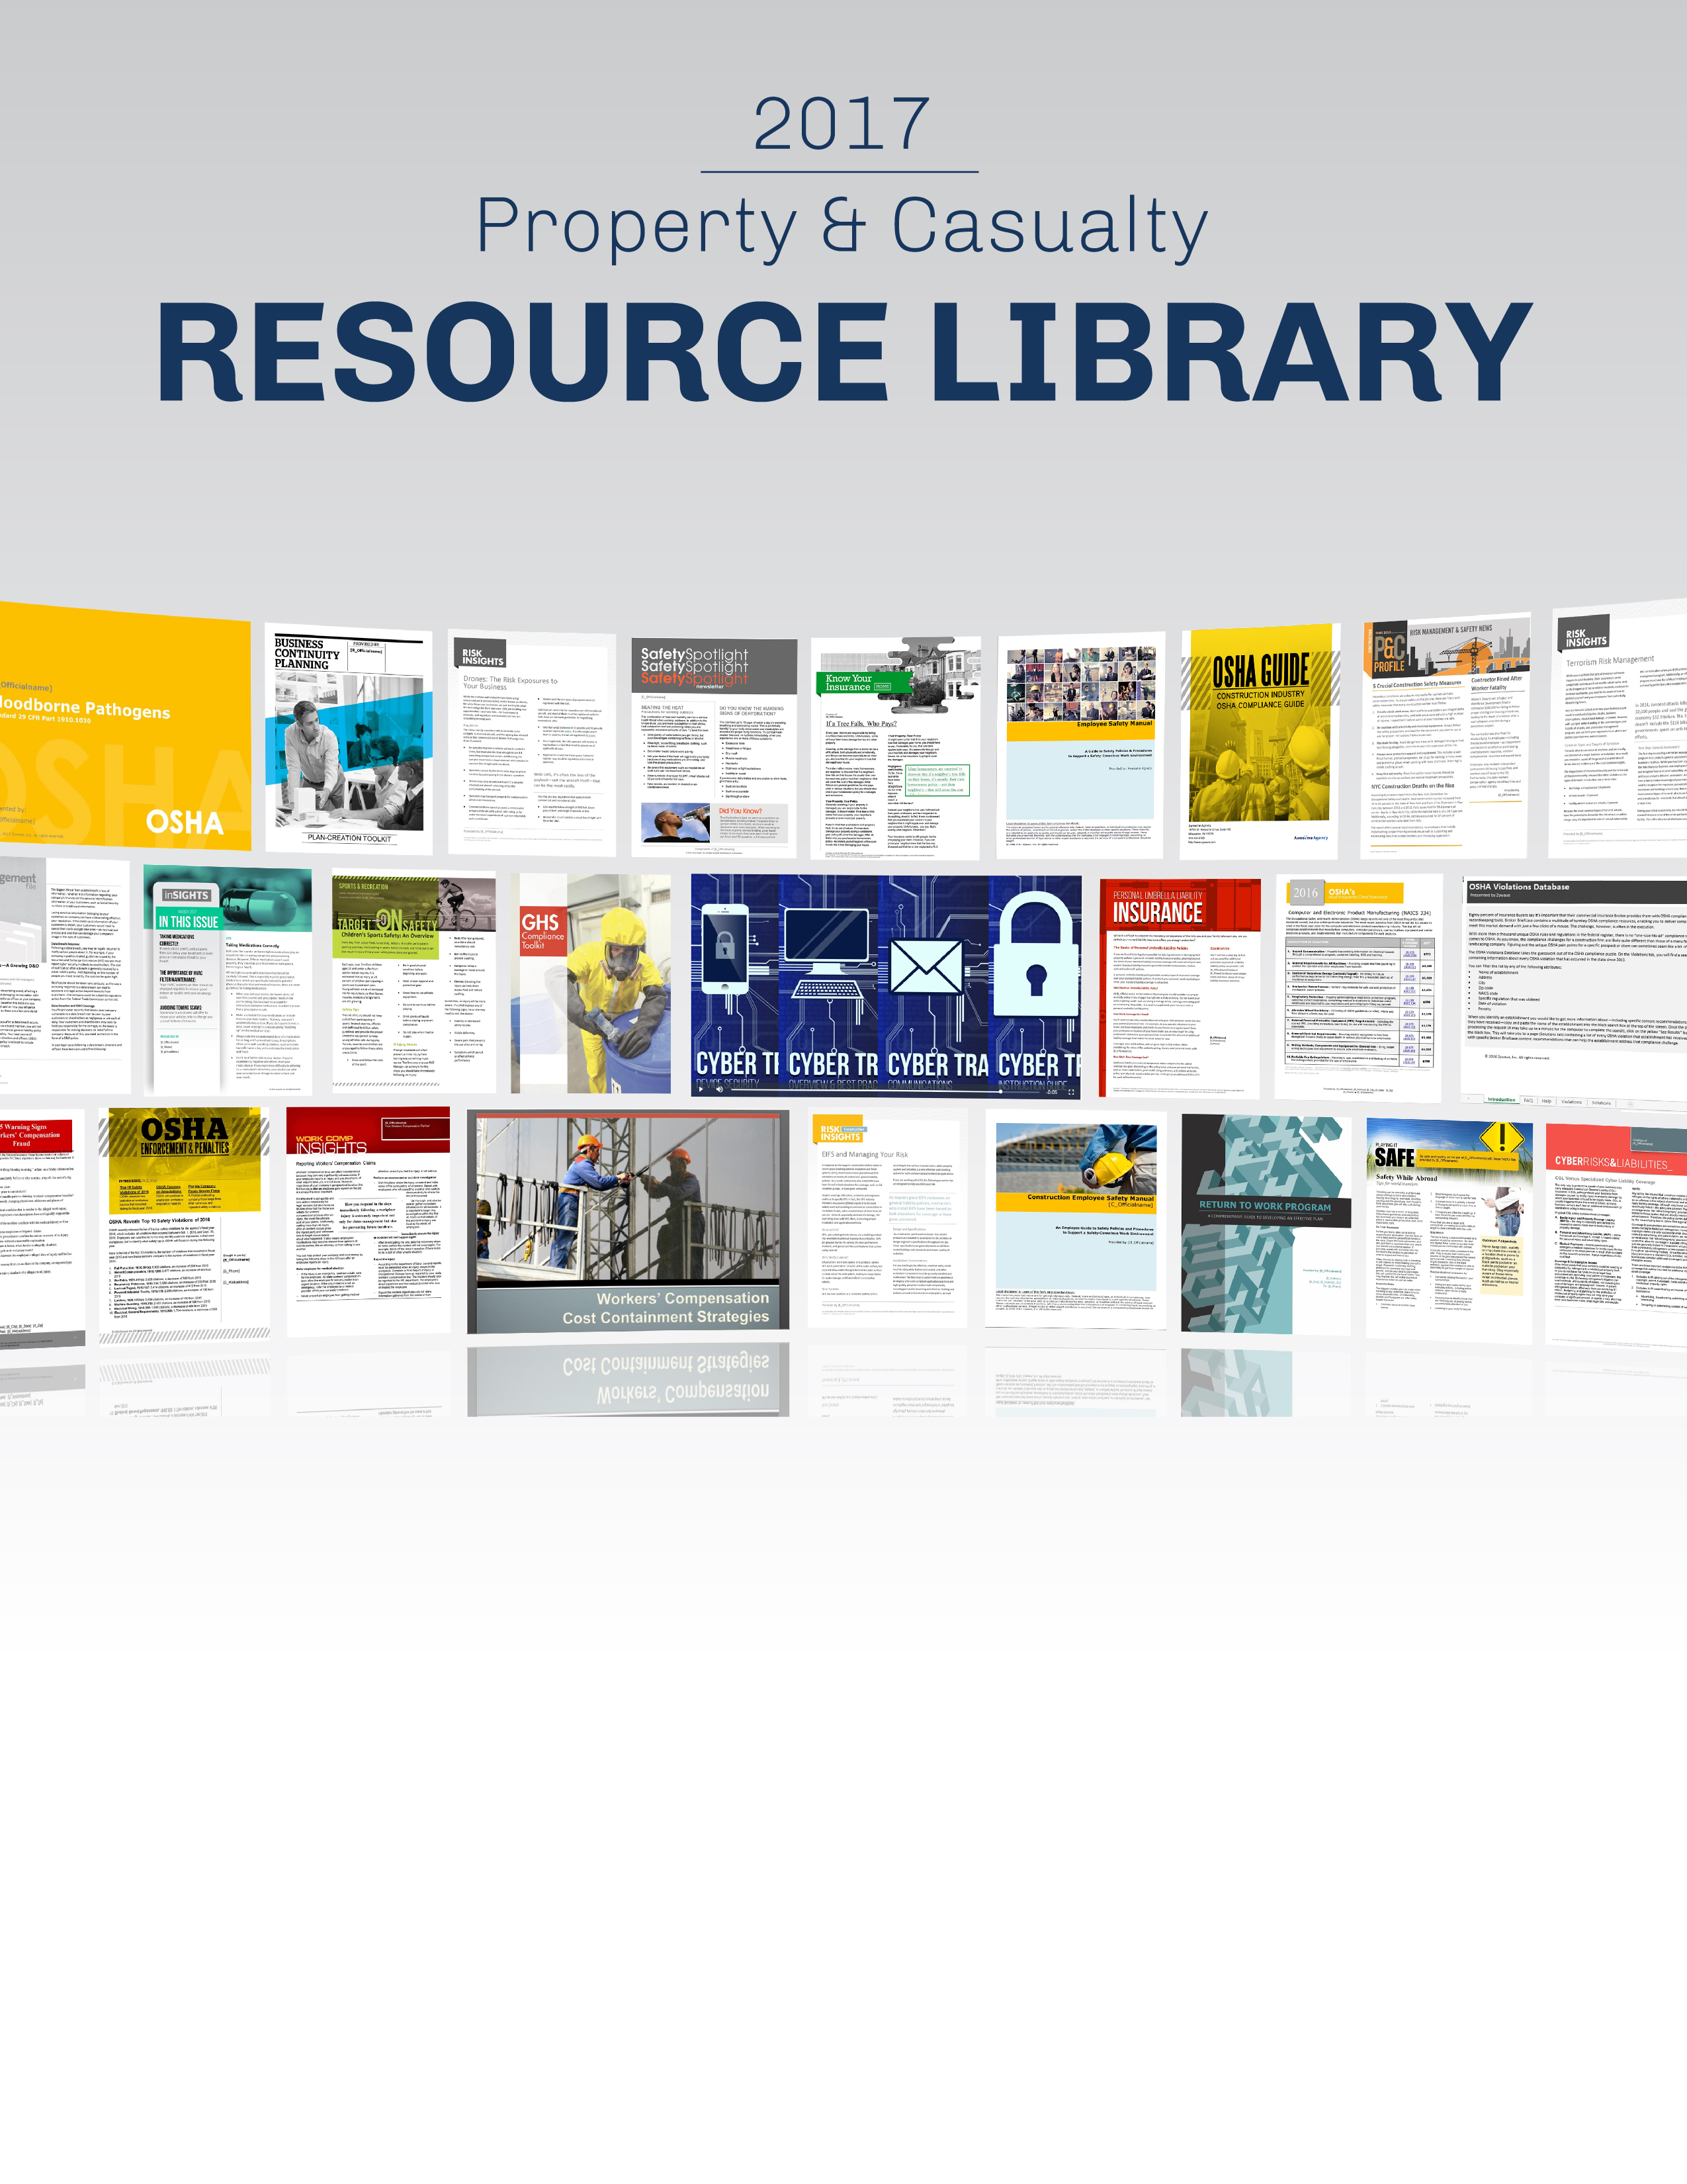
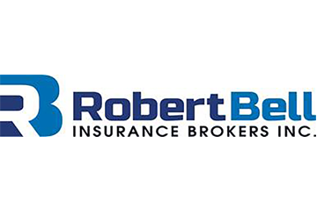
Robert Bell Insurance Brokers, Inc.
760-451-8556
www.robertbellinsurance.com

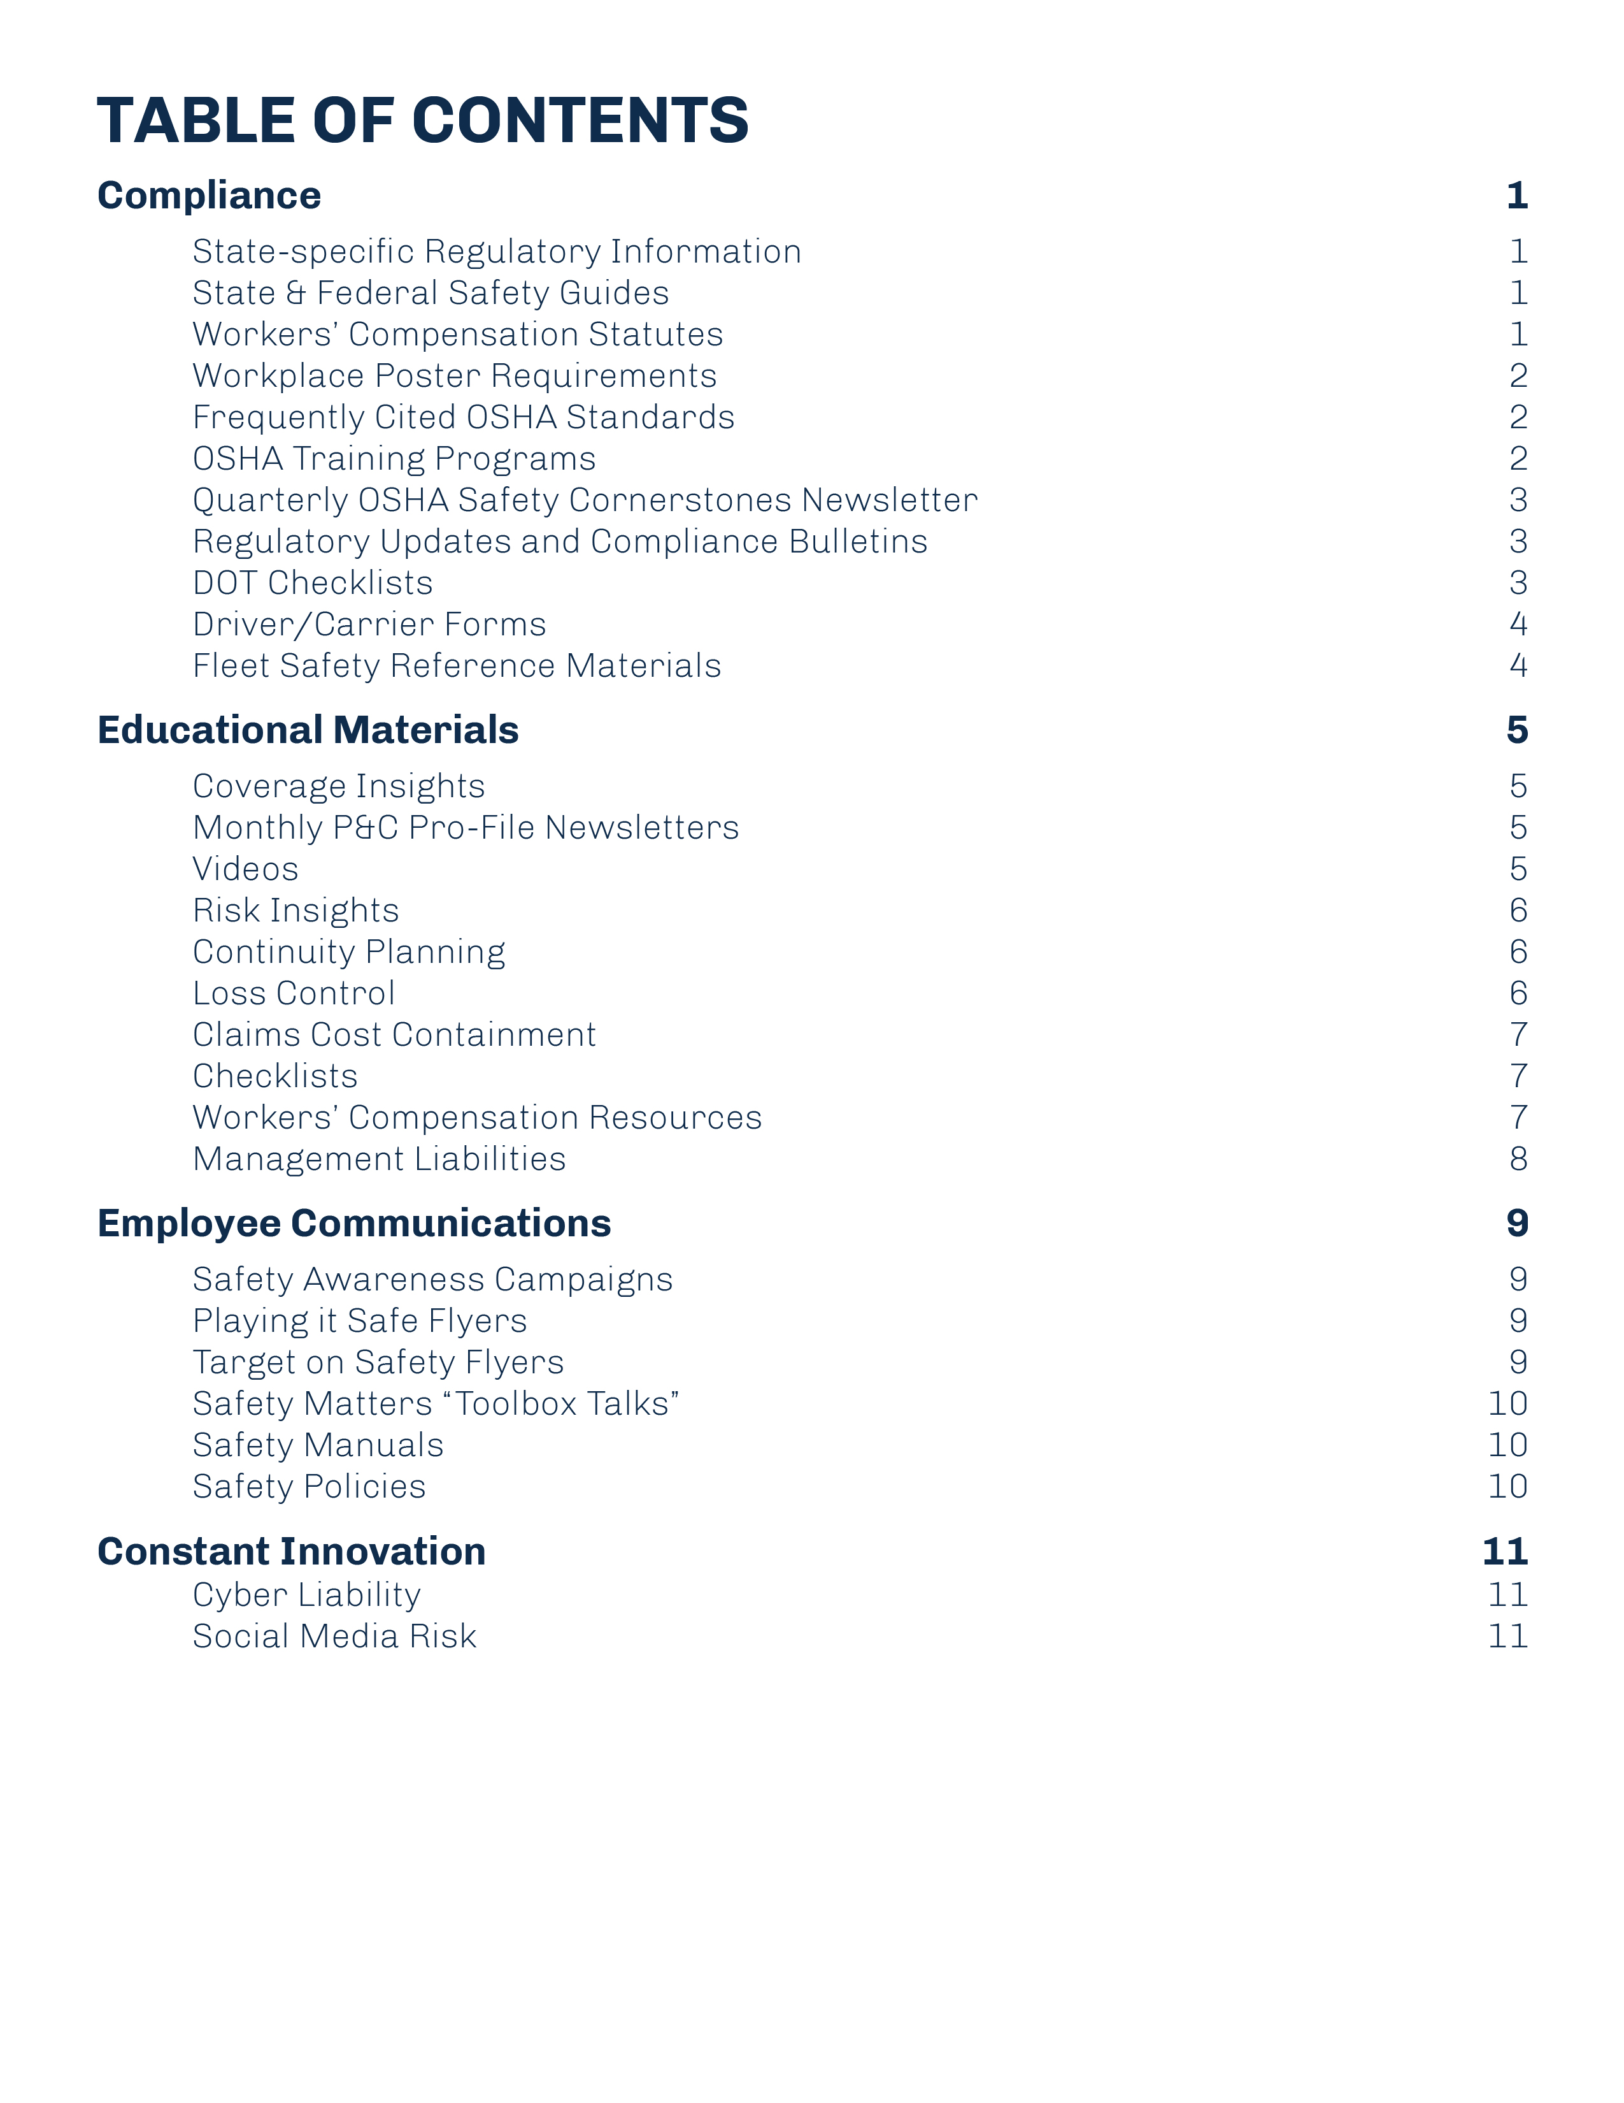
Whether you’re looking for safety training tools or searching for an answer to a pressing compliance question, Robert Bell Insurance Brokers, Inc. is dedicated to supporting your loss control, claims management, safety and compliance efforts. Our employee communications, workplace policies and industry-specific risk management tools will protect your business and increase your bottom line. This P&C resource library provides an overview of our content offerings with sample titles organized by topic.
To access any of the resources mentioned in this guide, simply contact Robert Bell Insurance Brokers, Inc. or visit your client portal. Read on to find out what we can do for you.
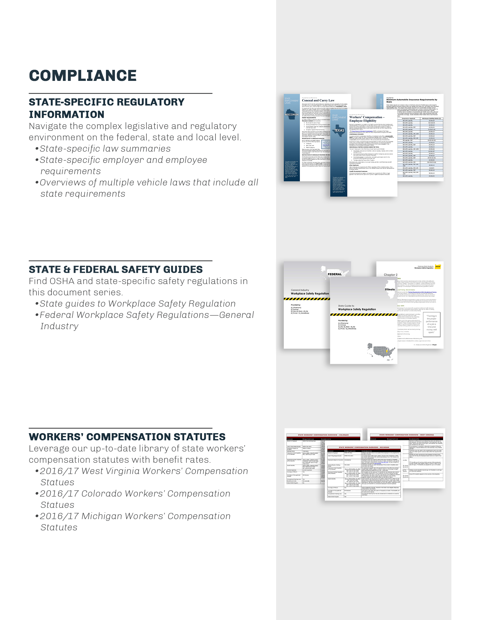
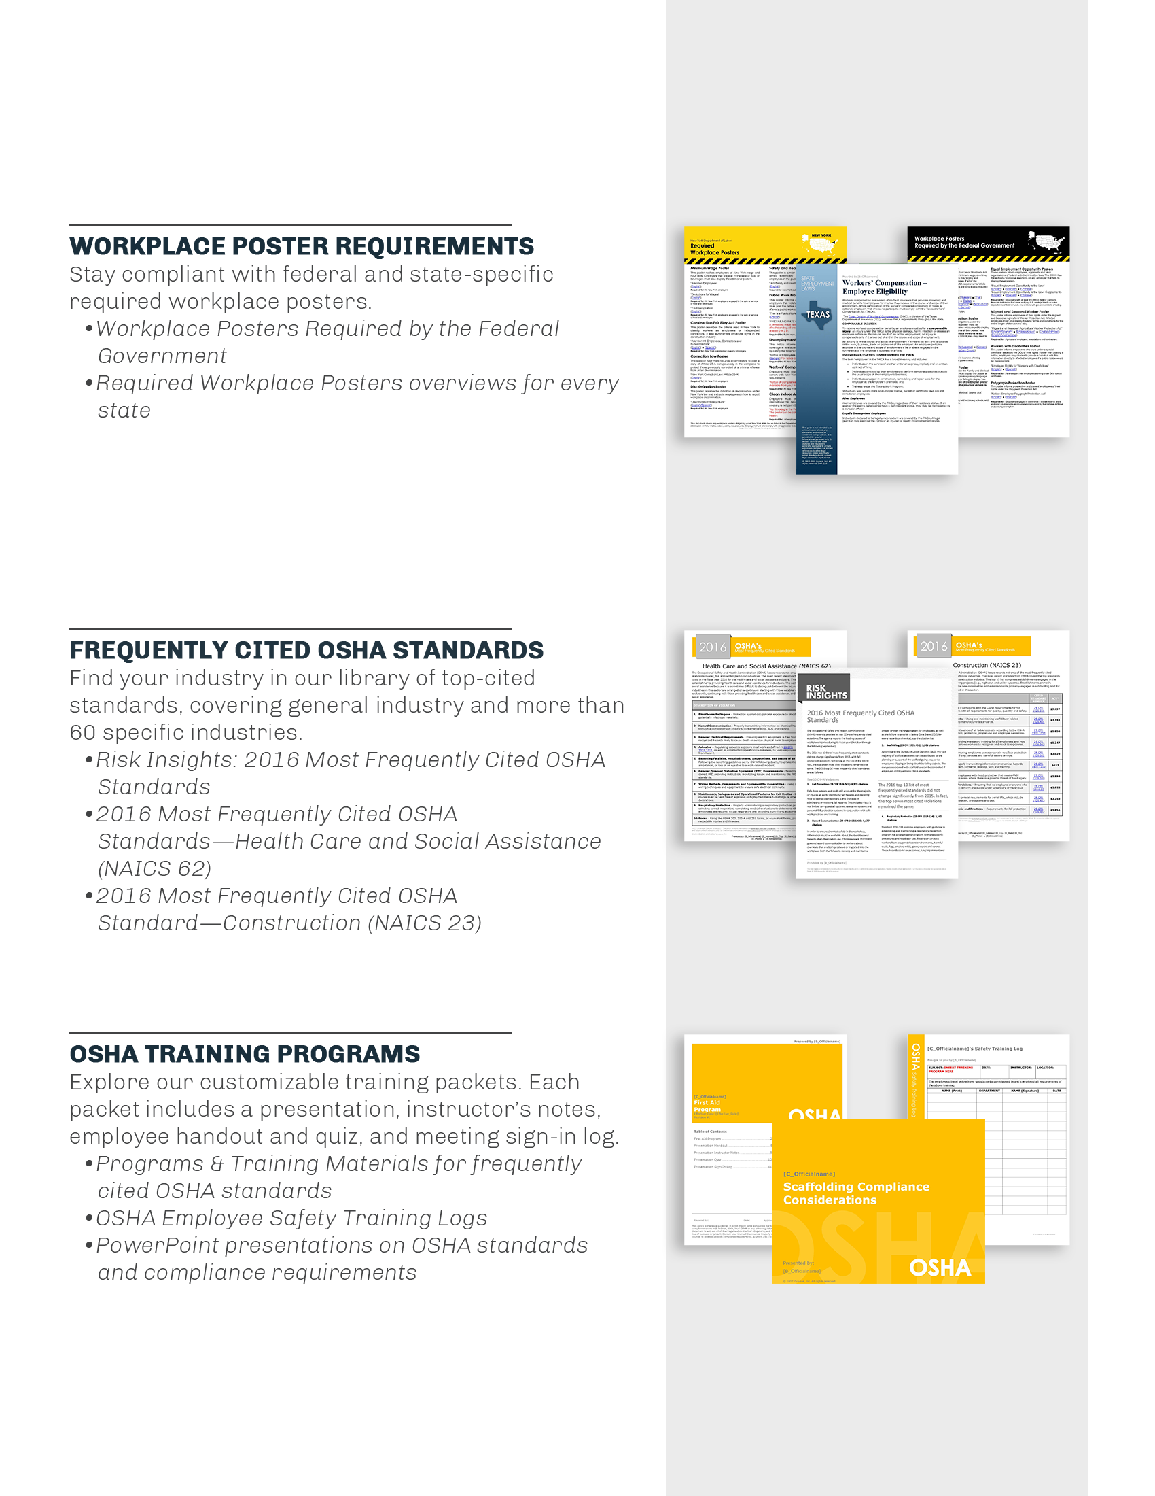
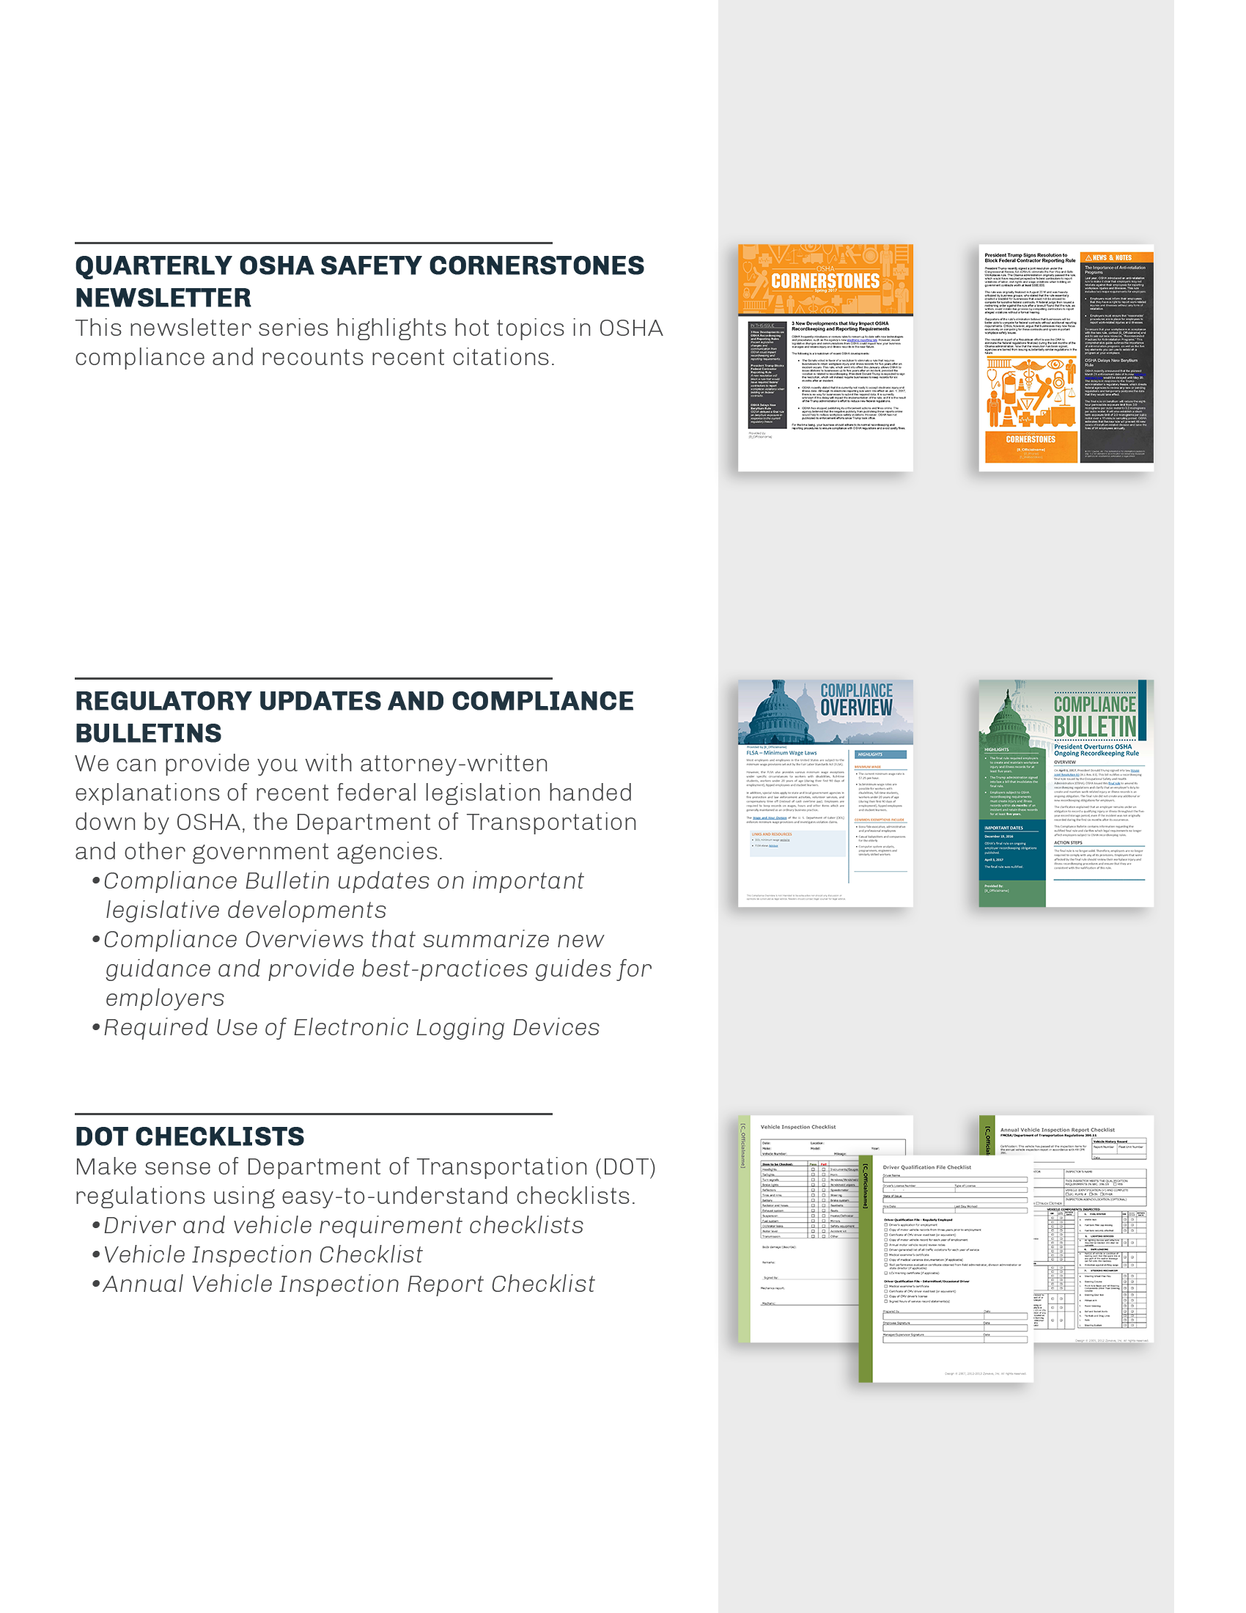

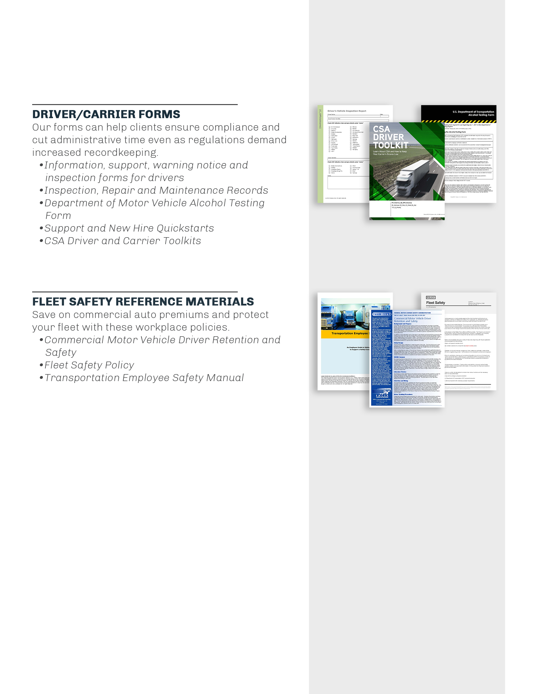

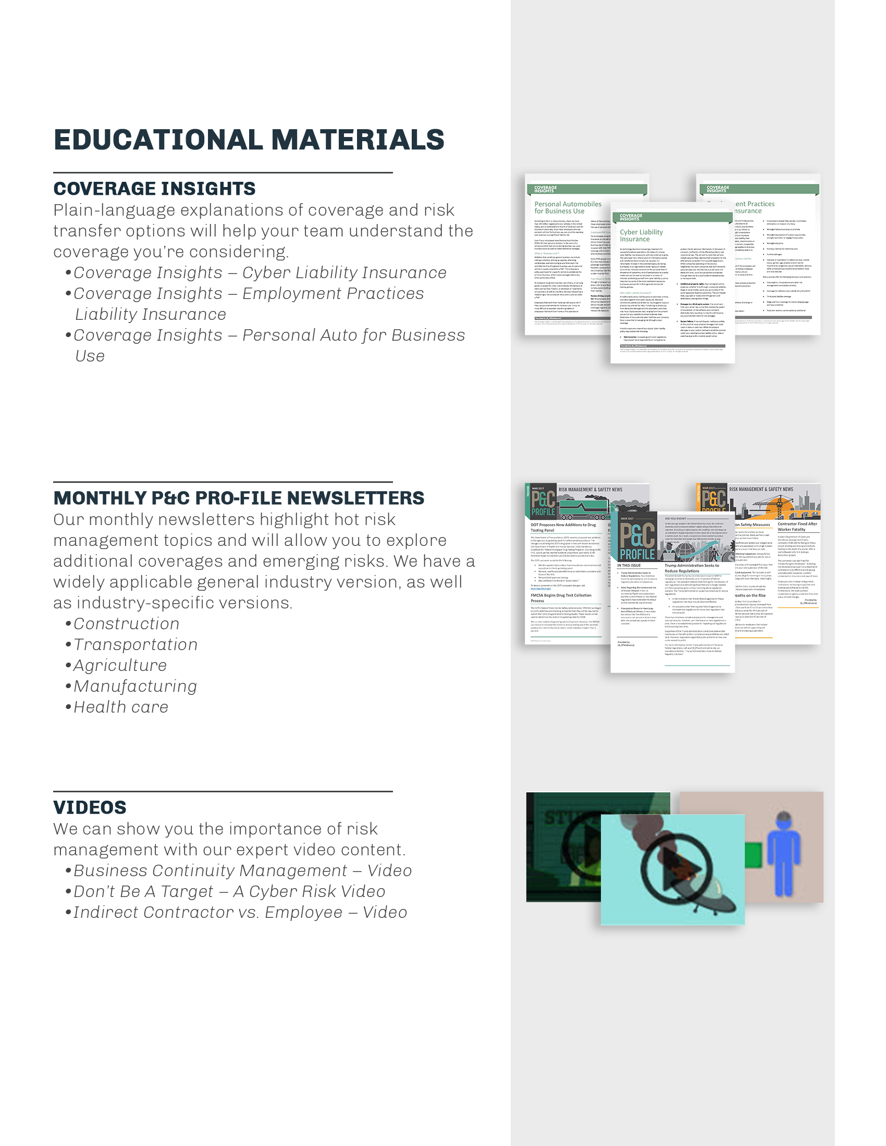

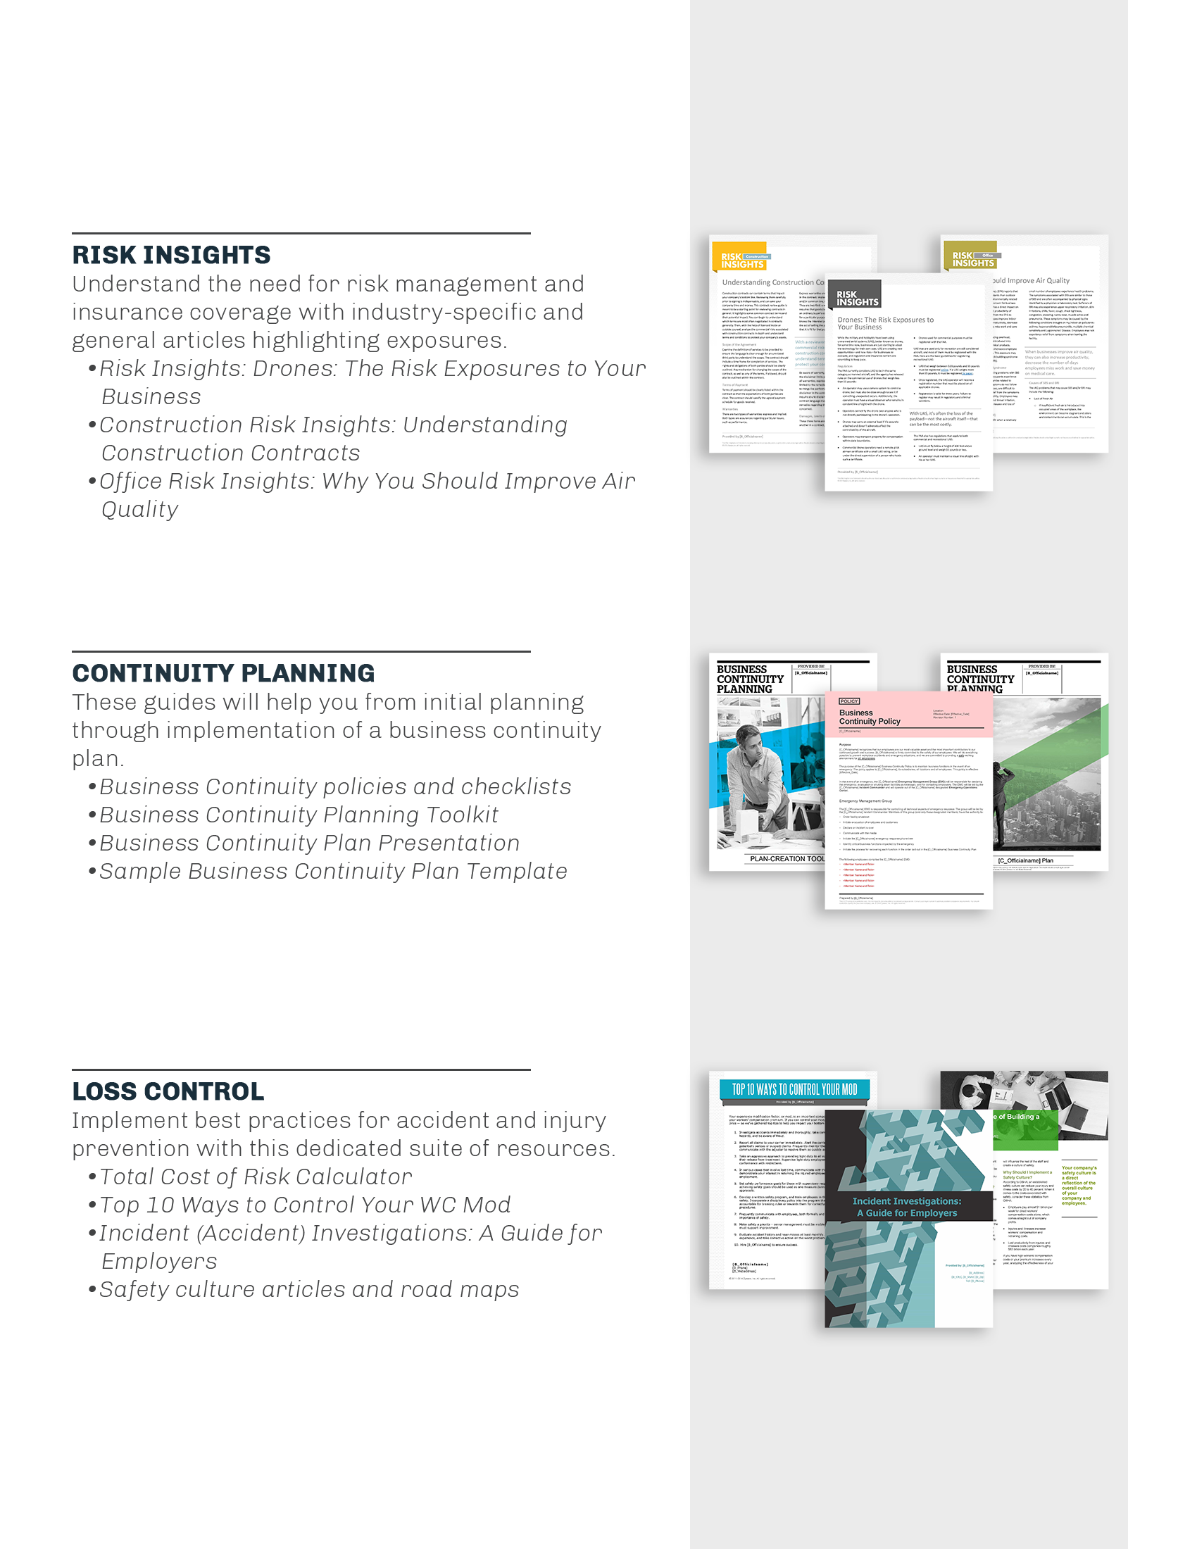

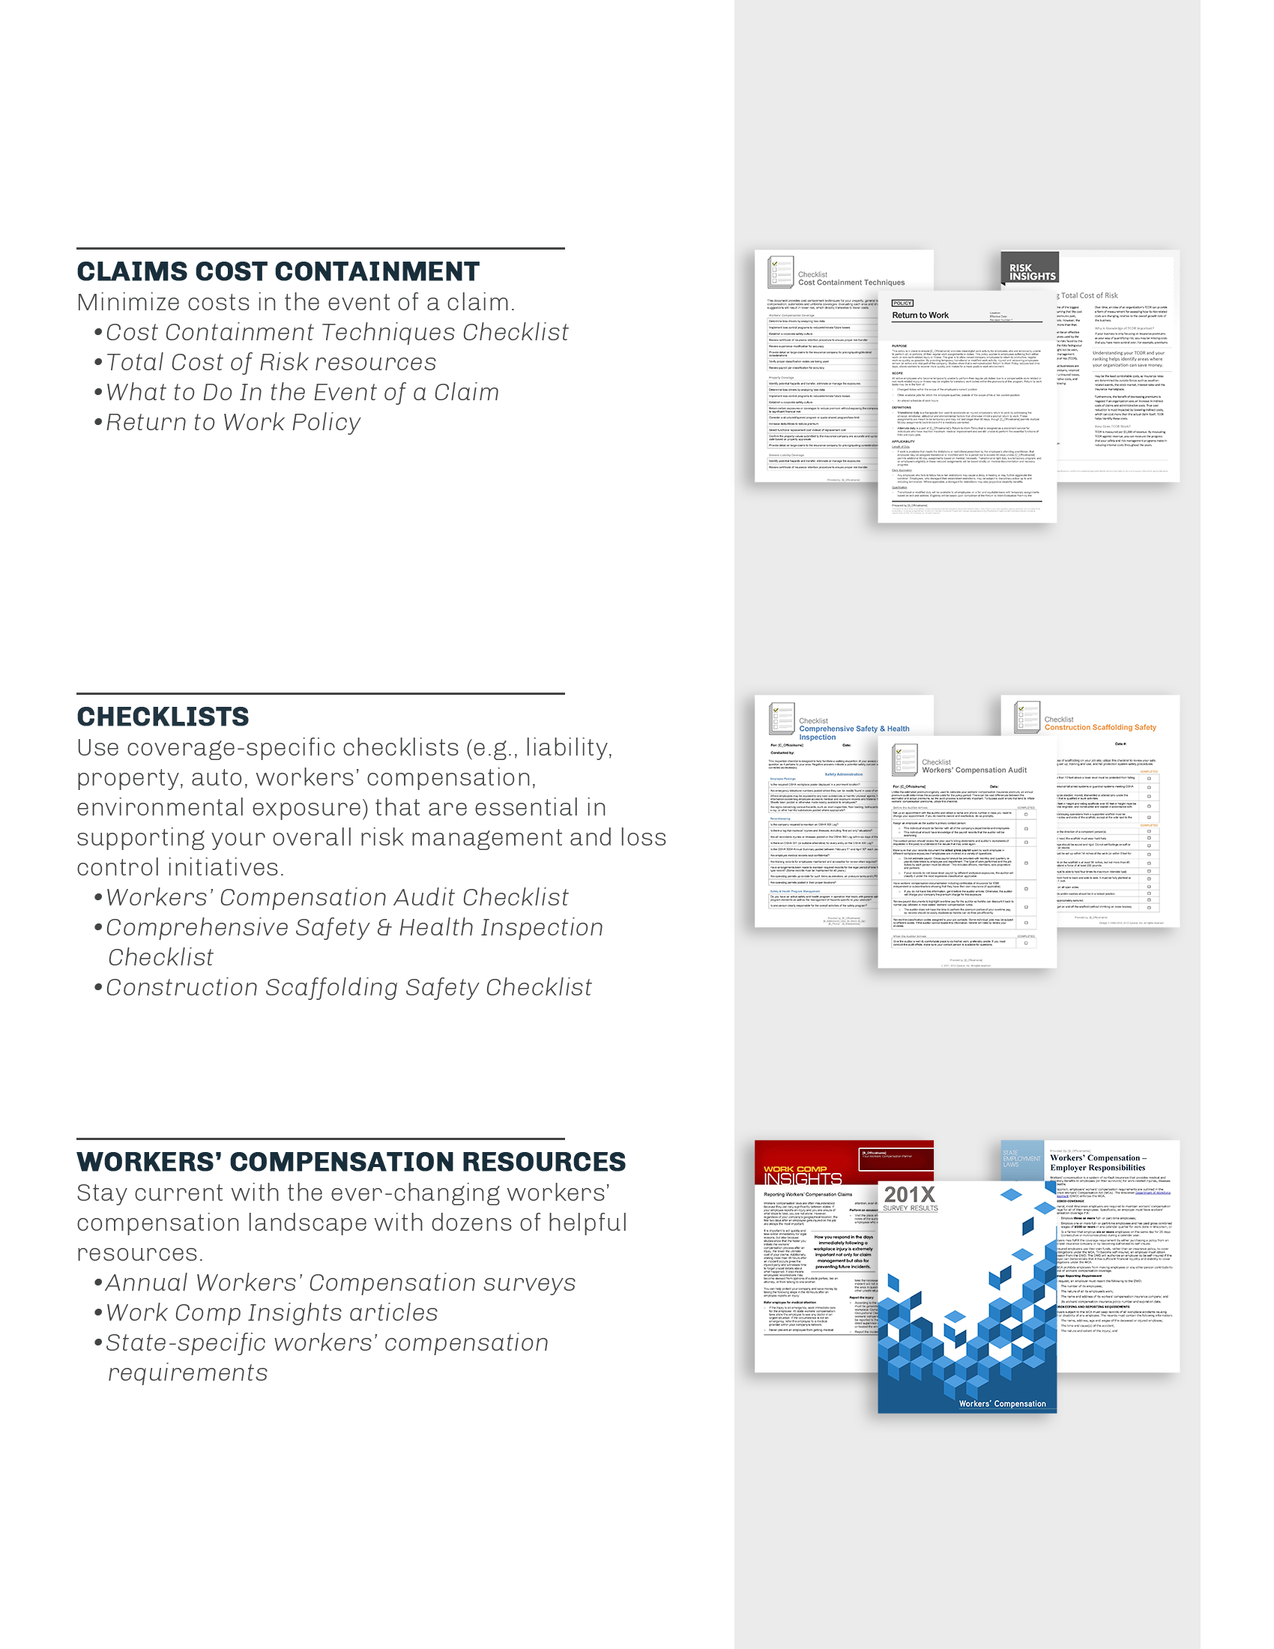

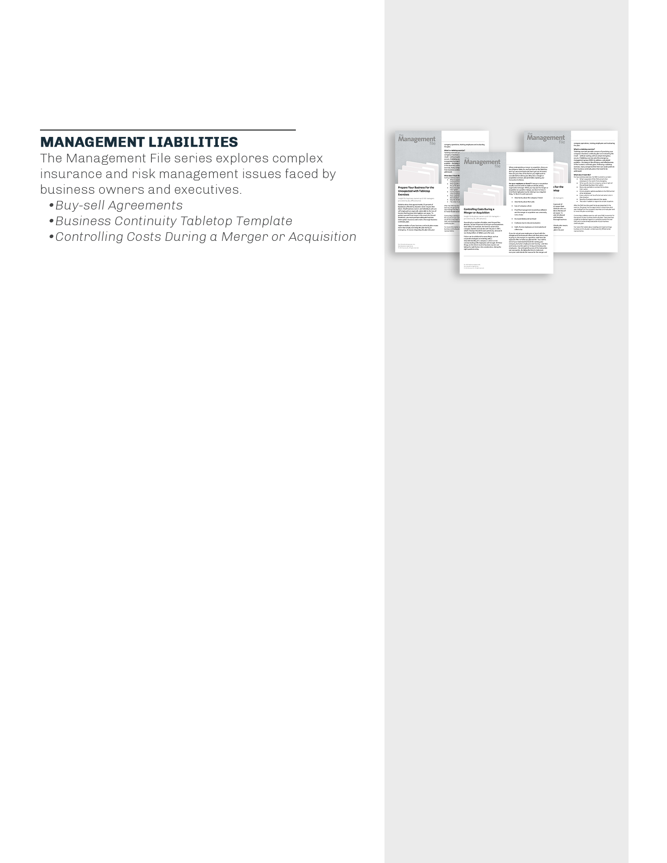

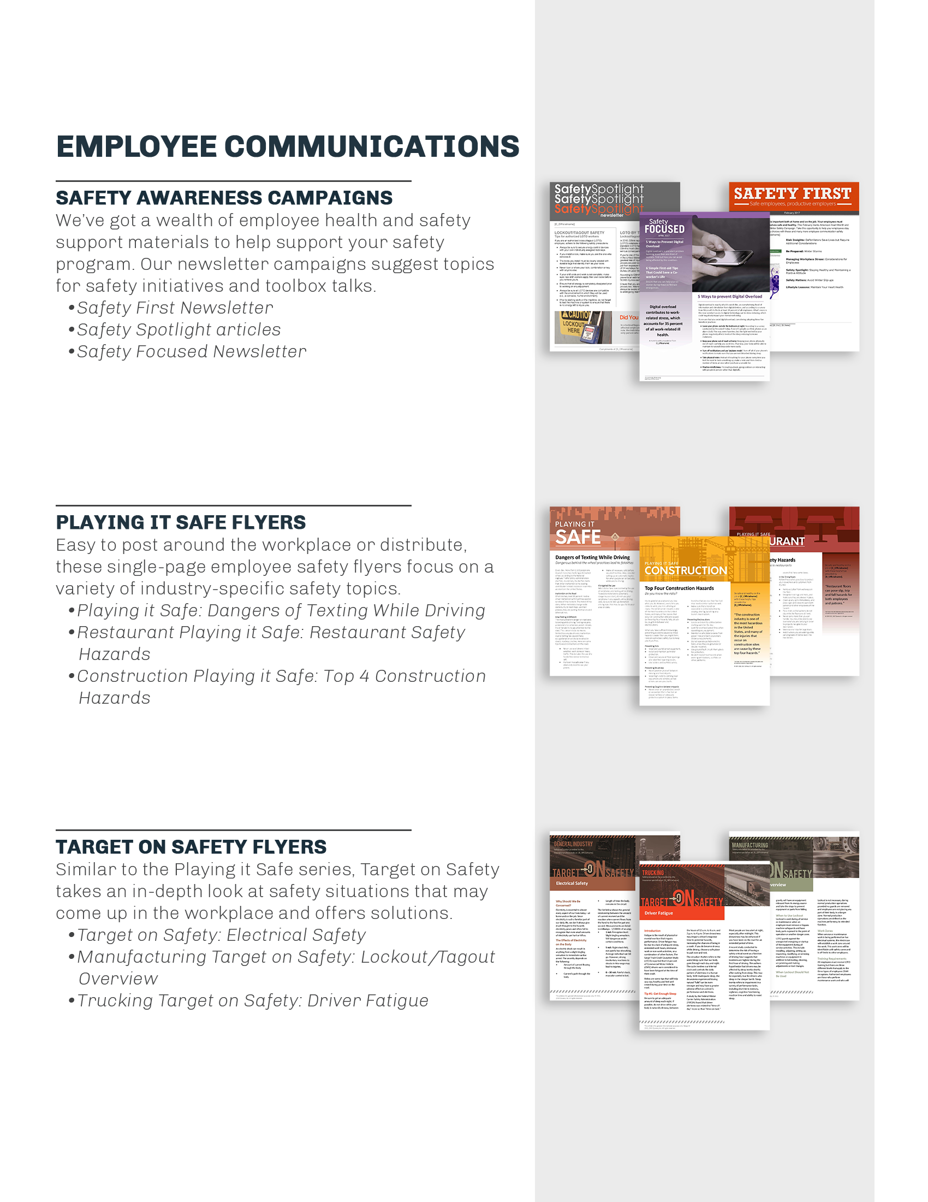

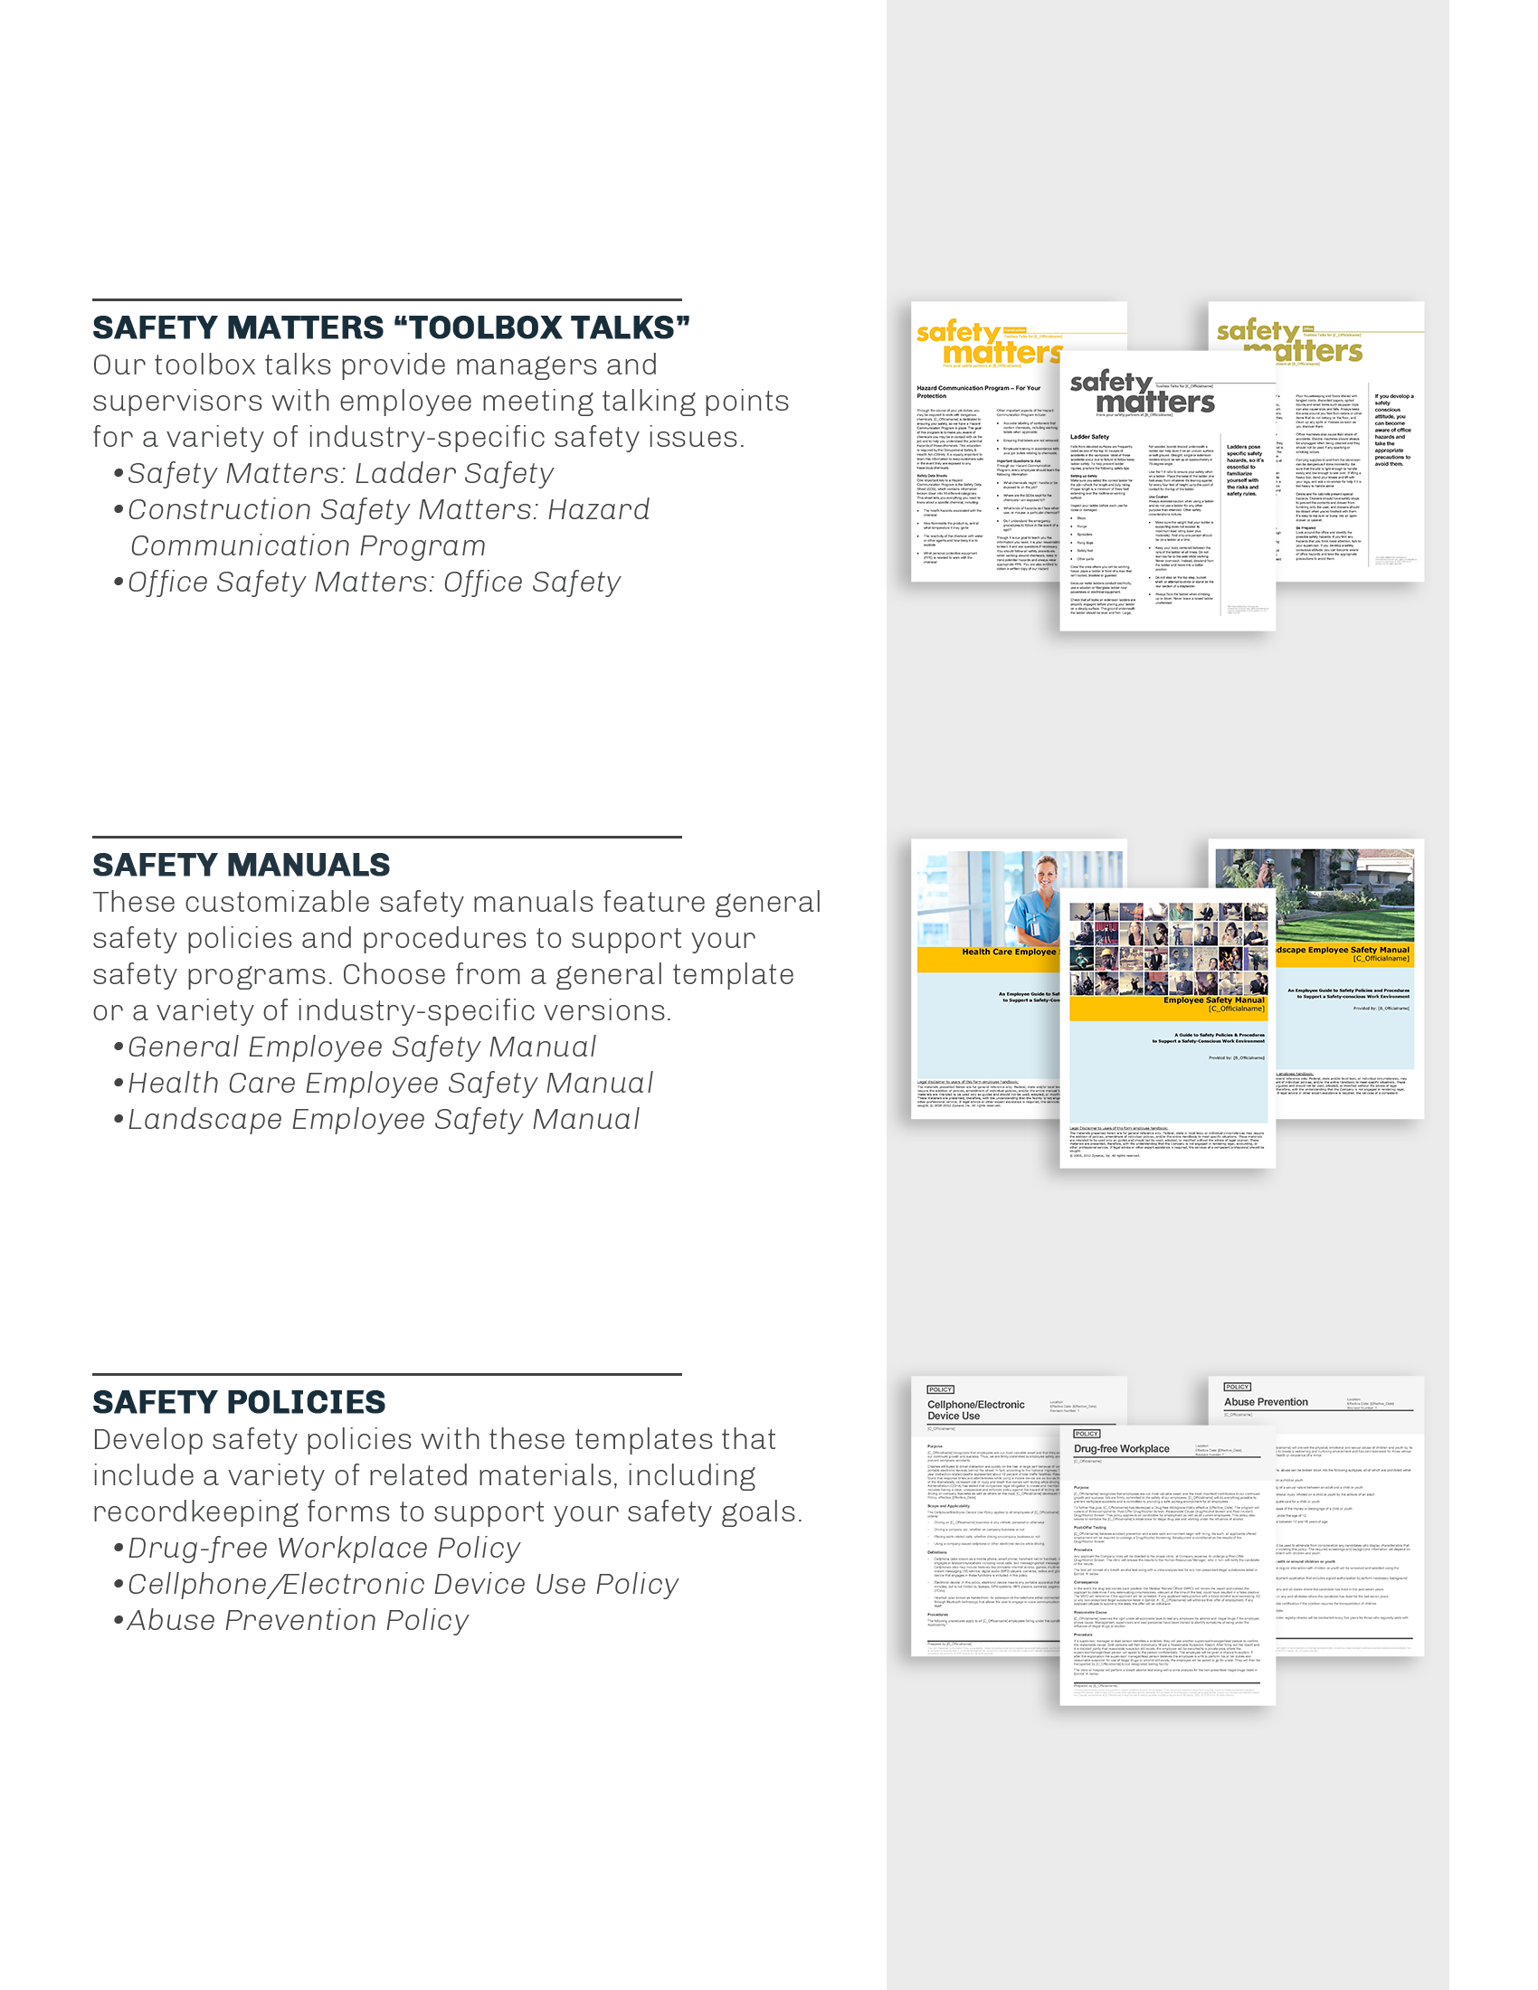

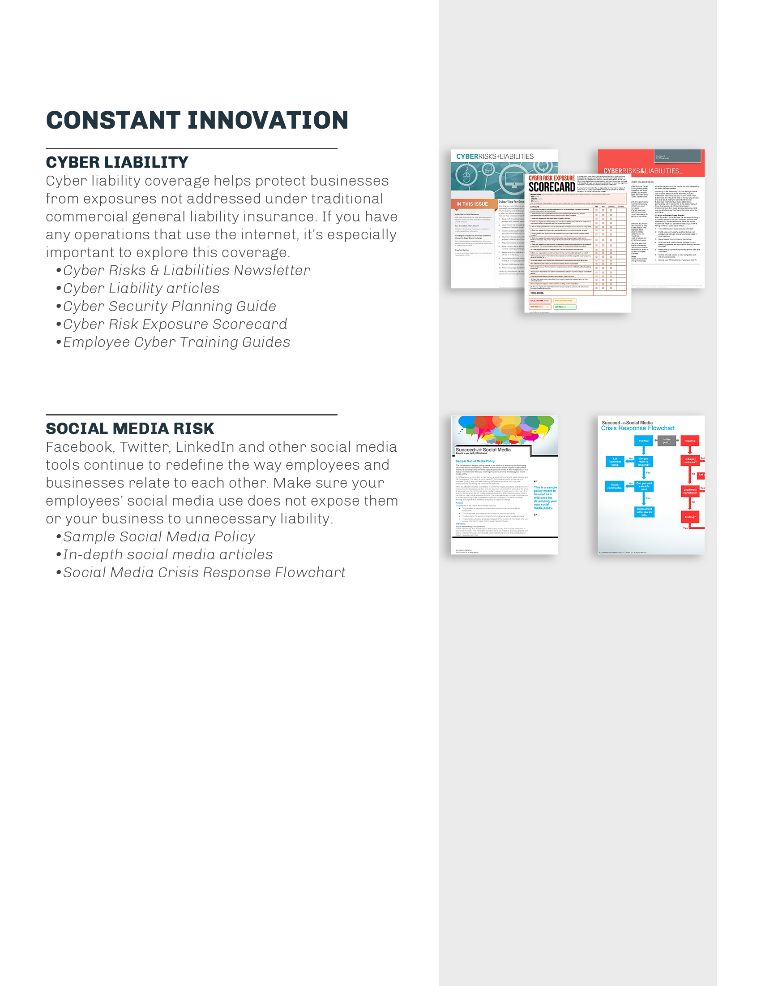

© 2012-2014, 2017 Zywave, Inc. All rights reserved.

